Copulas: EURUSD and AUDUSD
Method 18 / daily log returns / empirical ranks / Gaussian + Clayton / Alpari D1 full available history

Study setup
Logical pair: EURUSD , AUDUSD
Broker symbols: EURUSD_i , AUDUSD_i
Snapshot: 2026-11-03_majors_alpari_D1
Timeframe: D1
Matched return window: 1999-01-05 to 2026-11-02 (UTC bar dates)
Matched return count n: 7201
Dropped unfinished last bar dated 2026-11-03 UTC after a tick-volume check against the prior complete day.
Margins: empirical ranks / (n+1)
Families: Gaussian (rho) and Clayton (theta), fixed before ranking
Complete matched rows (Excel): EURUSD-AUDUSD_Copula_D1.xlsx
Complete matched rows (HTML table): EURUSD-AUDUSD_Copula_D1_data.html

Method carried forward
Copulas separate marginal return shapes from dependence on the unit square. Matched daily log returns of close, ln(close_t / close_t-1), are mapped to pseudo-observations u_i = rank(x_i)/(n+1) and v_i = rank(y_i)/(n+1). A Gaussian copula parameter rho is the Pearson correlation of Phi^{-1}(u) and Phi^{-1}(v). A Clayton copula theta >= 0 is fit by maximum likelihood on (u,v) for lower-tail asymmetry. Quotes are not inverted. Kendall tau implied by each fit and Spearman of (u,v) are stored. Same-sample Pearson r on returns is a side check. This is not causation and not a trading signal.

Results
Gaussian rho: 0.565780
Gaussian Kendall tau: 0.382849
Clayton theta: 0.865394
Clayton Kendall tau: 0.302016
Spearman of (u,v): 0.546799
Pearson r on returns: 0.556324

Conclusion
Over 7201 matched daily rows for EURUSD and AUDUSD, Gaussian copula rho = 0.5658 (Kendall=0.3828) and Clayton theta = 0.8654 (Kendall=0.3020). Spearman of (u,v) = 0.5468; Pearson r on returns = 0.5563. This is not causation and not a trading signal.

Charts
Daily closes

Daily log returns

Pseudo-observations (u,v)
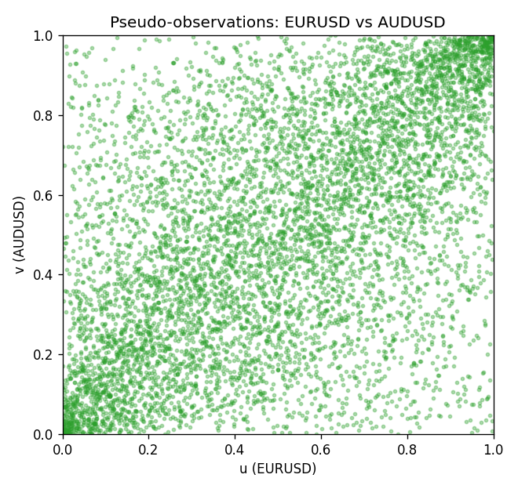

Data report
Every matched row is stored in the sibling Excel workbook named EURUSD-AUDUSD_Copula_D1.xlsx, including u and v. Embedding all rows as a Word table is impractical; this file holds column summaries and the first and last 15 matched rows.
Columns: time, EURUSD_open, AUDUSD_open, EURUSD_high, AUDUSD_high, EURUSD_low, AUDUSD_low, EURUSD_close, AUDUSD_close, EURUSD_tick_volume, AUDUSD_tick_volume, EURUSD_spread, AUDUSD_spread, EURUSD_real_volume, AUDUSD_real_volume, EURUSD_log_return, AUDUSD_log_return, u, v
Column summaries (matched calculation rows)
column | count | mean | std | min | 25% | 50% | 75% | max
EURUSD_open | 7201 | 1.1813268 | 0.15086382 | 0.8272 | 1.08608 | 1.16615 | 1.29393 | 1.5995
AUDUSD_open | 7201 | 0.75197127 | 0.13525779 | 0.4785 | 0.66105 | 0.73142 | 0.80912 | 1.10284
EURUSD_high | 7201 | 1.1864593 | 0.1514619 | 0.8326 | 1.0902 | 1.17128 | 1.29926 | 1.6038
AUDUSD_high | 7201 | 0.75602178 | 0.13581838 | 0.4878 | 0.6647 | 0.7349 | 0.81518 | 1.10795
EURUSD_low | 7201 | 1.1763142 | 0.15018707 | 0.8227 | 1.08202 | 1.16257 | 1.28834 | 1.5865
AUDUSD_low | 7201 | 0.74791431 | 0.13457219 | 0.4775 | 0.6577 | 0.72758 | 0.8042 | 1.0975
EURUSD_close | 7201 | 1.1813656 | 0.15083992 | 0.8267 | 1.08601 | 1.16617 | 1.29395 | 1.5997
AUDUSD_close | 7201 | 0.75202148 | 0.13524071 | 0.4786 | 0.6612 | 0.73175 | 0.80916 | 1.10169
EURUSD_tick_volume | 7201 | 103004.8 | 173409.64 | 469 | 9389 | 52708 | 99441 | 1471626
AUDUSD_tick_volume | 7201 | 77347.024 | 138135.9 | 109 | 5434 | 43320 | 71320 | 1234623
EURUSD_spread | 7201 | 19.396195 | 16.574381 | 0 | 8 | 12 | 30 | 50
AUDUSD_spread | 7201 | 30.819886 | 16.887485 | 0 | 13 | 30 | 50 | 50
EURUSD_real_volume | 7201 | 4.0238636e+10 | 1.6675367e+11 | 0 | 0 | 0 | 0 | 3.6149665e+12
AUDUSD_real_volume | 7201 | 5.2420906e+09 | 1.2538049e+11 | 0 | 0 | 0 | 0 | 3.811512e+12
EURUSD_log_return | 7201 | -7.54e-06 | 0.00580172 | -0.03123819 | -0.00324684 | 0 | 0.00325501 | 0.03433183
AUDUSD_log_return | 7201 | 2.459e-05 | 0.00754509 | -0.08602525 | -0.00385511 | 0.00028229 | 0.00415126 | 0.0806166
u | 7201 | 0.5 | 0.28865509 | 0.00013885 | 0.25006943 | 0.4994446 | 0.74993057 | 0.99986115
v | 7201 | 0.5 | 0.28865508 | 0.00013885 | 0.25006943 | 0.5 | 0.74993057 | 0.99986115
First 15 matched rows (selected columns)
time | EURUSD_log_return | AUDUSD_log_return | u | v
1999-01-05 | -0.0048360507 | -0.00080418179 | 0.16925854 | 0.43099139
1999-01-06 | -0.011547966 | 0.011836351 | 0.028186615 | 0.95848375
1999-01-07 | 0.0076280636 | 0.0088650256 | 0.91932796 | 0.91696751
1999-01-08 | -0.010902799 | 0.00031515916 | 0.032629825 | 0.50222161
1999-01-11 | -0.007103287 | 0.0072213815 | 0.096223271 | 0.87767287
1999-01-12 | 0.0045103728 | -0.0048608485 | 0.81935573 | 0.20535962
1999-01-13 | 0.010845346 | -0.0078902098 | 0.96653707 | 0.11121911
1999-01-14 | 0 | -0.002696916 | 0.4994446 | 0.31171897
1999-01-15 | -0.010153245 | 0.007123101 | 0.039988892 | 0.87364621
1999-01-18 | 0.0036256946 | 0.00094592471 | 0.77464593 | 0.54665371
1999-01-19 | -0.00017235436 | 0.0072225153 | 0.48430991 | 0.87781172
1999-01-20 | -0.0031939256 | 0.0012507819 | 0.25367953 | 0.566787
1999-01-21 | 0.0030215416 | 0.00078094498 | 0.73576784 | 0.53540683
1999-01-22 | -0.0012075213 | -0.012252745 | 0.39336295 | 0.044015551
1999-01-25 | -0.0030251979 | -0.0039591468 | 0.26339906 | 0.24465426
Last 15 matched rows (selected columns)
time | EURUSD_log_return | AUDUSD_log_return | u | v
2026-10-13 | 0.0037402957 | 0.0035007712 | 0.7817273 | 0.71257984
2026-10-14 | -0.0037582255 | -0.0015193215 | 0.22424327 | 0.38225493
2026-10-15 | 0.0056053107 | -0.0075447063 | 0.86573174 | 0.11788392
2026-10-16 | 0.0017724895 | 0.0033906408 | 0.64981949 | 0.70674813
2026-10-19 | -0.0025394633 | 0.0050859986 | 0.29644543 | 0.79533463
2026-10-20 | 0.0023881672 | 0.0034620426 | 0.69327964 | 0.71049708
2026-10-21 | -0.00032046717 | 0.0036066384 | 0.47139683 | 0.7193835
2026-10-22 | -0.0015949606 | -0.0012672558 | 0.36392669 | 0.40016662
2026-10-23 | -0.001338521 | 0.0023765656 | 0.38294918 | 0.63815607
2026-10-26 | -0.0022706559 | -0.0032032829 | 0.31338517 | 0.28297695
2026-10-27 | -0.004152342 | 0.0016669876 | 0.20105526 | 0.59094696
2026-10-28 | 0.0022262927 | 0.0040915541 | 0.68314357 | 0.74687587
2026-10-29 | 0.0022571351 | -0.0040915541 | 0.68578173 | 0.23910025
2026-10-30 | -0.0011458446 | 0.0010102376 | 0.39863927 | 0.54984726
2026-11-02 | 0.002120569 | -0.0049184984 | 0.67689531 | 0.20272147

